Wave Shaping Circuits with Diodes

Aim: To study clipping and clamping circuits.
Background: Clipping circuits allow that portion of the input waveform which lies above or below some reference voltage level. Broadly, clippers are classified into two categories:
- Shunt clipper
- Series clippers
Shunt clipper: The shunt clippers are the circuits in which the diode is connected across the load. The operation of the shunt clipper shown in Fig. 1(a) can be well understood using piecewise linear approximation model.
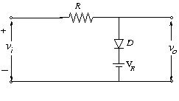
Figure 1(a)
In Fig. 1 (a), the cathode of the diode D is held at +V_{R}. Hence, for the diode to conduct, the input signal has to be greater than V_{R}+ Vγ, where Vγ is the cut-in voltage of the diode.
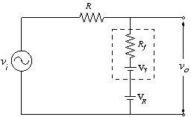
Figure 1(b)

Replacing the diode by its equivalent circuit shown in fig. 1(b) and applying KVL, we get
V_{i} = i.R+ V_{o} ------------------------------------------ (1)
V_{i} = i.R + i.R_{f}. +Vγ + V_{R} ----------------------------------------------------------------- (2)
i= 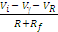
This gives,
V_{o}= + V_{R} + Vγ --------------------------------- (3)
Simplifying this, we get,
V_{o} = ---------------------------------------- (4)
- When input signal V_{i} is less than (V_{R}+ Vγ), D is OFF (i=0).
Hence, from Eq. 1, we get V_{o} = V_{i}.
- For the diode D to conduct, V_{i} should be greater than V_{R} + Vγ. When the diode conducts, the output signal is given by the Eq. 4.
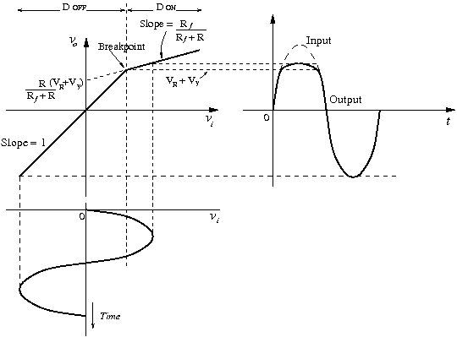
Figure 1(c)
The transfer characteristics can be drawn to illustrate both the conditions as shown in Fig. 1(c).
The transfer characteristics indicate an abrupt change in slope at V_{i}= V_{R}+ Vγ (breakpoint). When the input voltage is less than (V_{R}+ Vγ), diode D is OFF and V_{o}= V_{in}, indicated by slope 1. When the input voltage is greater than (V_{R}+ Vγ) (to the right of the breakpoint), the characteristics is a line with slope given by the Eq. 4.
Since R_{f} << R and Vγ << V_{R}. Eq. 4 reduces to
V_{o} = V_{R} + Vγ.
Thus the output waveform is found to have “clipped off” the positive peak above (V_{R}+ Vγ).

Series clipper: These are the clipping circuits in which the diode is connected in series with the load (see Fig. 2(a)).
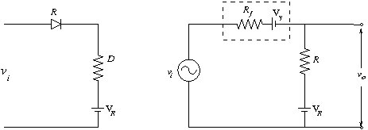
Figure 2(a) Figure 2(b)
Here, the cathode of the diode is held at V_{R.} .So, the diode conducts for V_{i} > V_{R} + Vγ.
Applying KVL to the circuit in Fig. 2(b),
V_{i} = i. (R_{f} + R) + Vγ + V_{R}
i=
V_{o} = i.R + V_{R}
V_{o} = 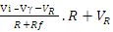
V_{o} = + -
Since R >> R_{f}, ≈ 0, and ≈ 1
Hence, V_{o} = V_{i} - Vγ.
For V_{i} < V_{R} + Vγ the diode does not conduct (i = 0),
Vo = V_{R}.
Thus, that portion of the waveform is transmitted which lies above V_{R.}
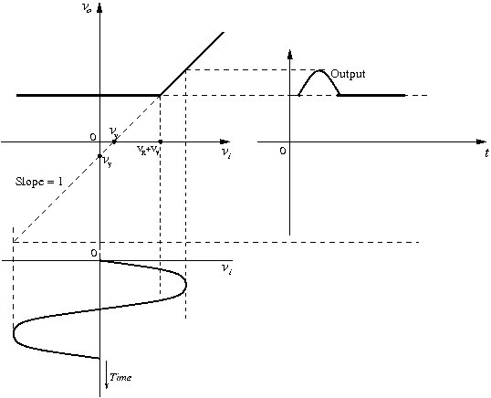
Figure 2(c)
Clamper Circuit
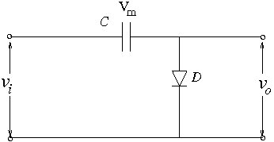
Figure 3(a)
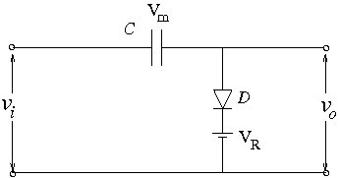
Figure 3(b)
Clamping circuits are used to hold either positive or negative extremity to a reference voltage level. Fig. 3(a) shows the clamper circuit that clamps the positive peak at zero level. The capacitor charges to V_{m} i.e. the peak value of the input signal during the first quarter positive cycle of the input signal. After the first positive peak, the input voltage starts falling. Since the capacitor has no path for discharge, it will hold +V_{m} across it preventing the diode to conduct. The output voltage is then given by V_{O} = V_{in} - V_{m}. Thus, whenever positive peak occurs, (V_{in} = V_{m}), the output is clamped to zero volts.
In Fig. 3(b), by inserting a reference voltage between the cathode of the diode and common, the positive extremity is held at +V_{R} level. In this case, the capacitor charges to voltage V_{m} - V_{R}. This gives rise to V_{O} = V_{in} – (V_{m} - V_{R} ).

Simulation assignments
Part I: Clipping Circuit 1
- Analyse the circuit of Fig. 1(a), and plot V_{o} versus V_{i} for -5V < Vi < 5V. Assume the diode voltage drop to be 0.7 V when conducting.
- Using the result of (a), plot the waveform V_{o} (t) versus time for a triangular input voltage V_{i} (t), varying from -5V to +5V, with a frequency of 1 kHz.
- Simulate the circuit and verify your answers of (a) and (b).

Part II: Clipping Circuit 2
- Analyse the circuit of Fig. 2(a), and plot V_{o} versus V_{i} for -5V < Vi < 5V. Assume the diode voltage drop to be 0.7 V when conducting.
- Using the result of (a), plot the waveform V_{o} (t) versus time for a triangular input voltage V_{i} (t), varying from -5V to +5V, with a frequency of 1 kHz.
- Simulate the circuit and verify your answers of (a) and (b).

Part III: Clamping Circuit
- Analyse the circuit of Fig. 3(a), and plot V_{o} versus V_{i} for -5V < Vi < 5V. Assume the diode voltage drop to be 0.7 V when conducting.
- Using the result of (a), plot the waveform V_{o} (t) versus time V_{i} (t)
- Plot the waveform V_{o} (t) versus time for a sinusoidal input voltage V_{i} (t), varying from -5V to +5V, with a frequency of 1 kHz.
- Simulate the circuit and verify your answers of (a) and (b).
- Repeat (a) – (d) for Fig. 3(b) with V_{R}=+1V and -1V.

Part IV: Diode clipper lab sessions
  - Wire the circuit shown in Fig. 4. Apply a sinusoidal 1 KHz input voltage (16V peak to peak). Observe and sketch in your report, V_{out} versus V_{in} in the X-Y mode for (a) V_{S} = 0V (i.e., ground), (b) V_{S} = +3V, (c) V_{S} = -3V. Explain your observations. Would you make these measurements in the AC or DC mode? Why?
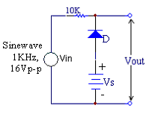
Figure 4
  - Design circuits to generate the input output characteristics given in Fig. 5 (a) and
5 (b). Wire the circuits and verify their operation.
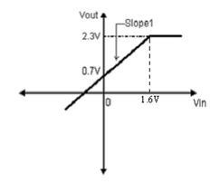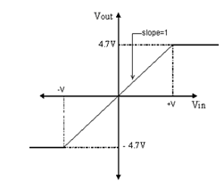
Figure 5(a) Figure 5(b)

